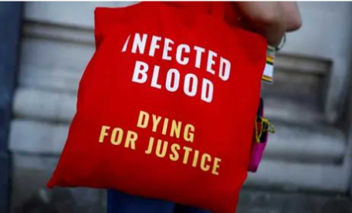

**Welcome to the Health and Social Care Pre-Induction Task**

This task is to promote your curiosity into current topics linked to Health and Social Care. We want you to demonstrate your skills and knowledge in a short task which will give you an idea of what you will complete over the next two years.

You need to. **Watch**: [**https://www.bbc.co.uk/news/videos/cw449k17j98o**](https://www.bbc.co.uk/news/videos/cw449k17j98o)



And then **Read**: [**https://news.sky.com/story/infected-blood-scandal-victims-could-receive-more-than-2m-compensation-13141045**](https://news.sky.com/story/infected-blood-scandal-victims-could-receive-more-than-2m-compensation-13141045)

***Then using what you have learnt answer the following questions…***

1. What is the main concern regarding infected blood in the UK?

A. Contaminated blood products

B. Lack of blood donors

C. Blood transfusion errors

D. Blood type mismatches

1. How many people, according to the video, were infected with hepatitis C and HIV due to contaminated blood and how do they know this?
2. What was the disease said to become the biggest scandal in the history of the NHS, what other scandals do you know and how does this compare?
3. What was the reason given for the delay in the official inquiry into contaminated blood and explain what this is?
4. How do you think this will make users of NHS feel and how may this impact on future care for service users?

***We would like you to either record your answers by hand or to type in a word document. Consider your use of spelling, punctuation and grammar.***