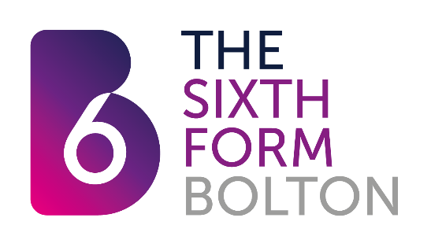

**Careers Education, Information, Advice and Guidance, (CEIAG) Policy**

**Rationale**

At The Sixth Form, CEIAG is embedded into all areas of the curriculum, so that our students are well informed and equipped for the next step of their career journey. We support students to ensure that they:

* Develop self-awareness of their skills, strengths and interests in relation to higher education and career options.
* Research their career ideas and HE goals.
* Understand Labour market Information and its impact on the choices that they make.
* Can confidently demonstrate the key employability skills required by employers.

**Aims**

1. To develop employability skills by offering careers-related activities within the curriculum, delivering the Professional Growth Programme and providing opportunities for students to undertake work experience.
2. To offer all students the opportunity for careers guidance with a qualified careers guidance practitioner, (students can self-refer for careers guidance appointments at any point during their time with us).
3. To support inclusion, challenge stereotypes and promote equality of opportunity across all areas of the sixth form.
4. To work closely with key partners within higher education and employment, so that students have direct access to relevant and accurate information which relates to their post-sixth-form career goals.
5. To enable parents and carers to support their son/daughter in their career planning, by providing access to key sources of careers information online and via in-college activities such as the Parents Progression Information evening.
6. To offer all staff the opportunity for CPD in relation CEIAG
7. To provide students with up-to-date careers material via: The careers resource area; the TEAMs virtual careers resource library; other online resources and on noticeboards around the sixth form.
8. To gather intended destination information at enrolment, which will enable the sixth form to identify and provide appropriate and relevant careers activities for students.
9. To work closely with key-staff in learning support, so that students with additional and higher needs have access to appropriate and timely careers information, advice and guidance.
10. To work closely with Progress Tutors, to ensure students who are at risk of becoming ‘NEET,’ receive timely interventions from the careers team and (where appropriate), referred to external careers support services.
11. To closely monitor the quality of the in-college careers provision via student, staff and parental surveys.

**Implementation**

1. Careers resource area – a range of materials, careers-related books and university prospectuses.
2. Virtual TEAMs careers resource library – contains a variety of career and university subject videos, which students can browse and watch at their leisure.
3. Careers notice boards – Key information on digital screens around college. Notice boards with specific information on employability and university provision.
4. Career exploration and work experience opportunities are shared with students and staff via the TEAMS platform as well as information on CV writing, personal statement writing, interview technique etc.
5. Careers learning and exploration opportunities are promoted to staff and students via the monthly newsletter and during tutor group sessions.
6. Careers Adviser – available for appointments 5 days a week.
7. Annual Careers day – including careers marketplace and careers/university workshops.
8. Progression information evening for parents, covering the higher education application and finance system and degree apprenticeships.
9. Weekly tutor groups which offer students the opportunity explore and prepare for life after sixth-from.
10. Visits to universities and employment sectors via subject areas and careers department.
11. Students encouraged to get involved in the wide range of enrichment activities during their time at The Sixth Form.
12. Labour market/careers information displayed in classrooms.
13. Bespoke careers-related talks and workshops offered throughout the academic year and delivered by a range of organisations including, Hewlett Packard, SUEZ recycling, Operating Theatre Live, NHS, a range of universities, Social Mobility Foundation, etc.
14. Professional Growth Programme provides the opportunity for career exploration, understanding of LMI and development of key employability skills which are relevant to individual student’s career area of choice. This is delivered as a hybrid of in-person employability sessions and online learning modules.
15. Personal statement 1:1 workshops offered by a range of HE professionals.

**Monitoring, Review and Evaluation of the CEIAG Policy**

1. Careers programme reviewed and updated annually.
2. Records kept to monitor careers-related learning activities within departments, using the Careers Tracker on DAVE.
3. Careers log keeps a record of all careers guidance appointments and action plans recorded against students using the Careers tracker on DAVE.
4. Student, parent and staff feedback feeds into the development of the careers programme.
5. Regular Compass assessment against the Gatsby benchmarks.
6. Careers resources updated by the careers team.
7. Progression data and NEETS will be reviewed annually and reported to Governors.
8. Intended destination data informs content and delivery of careers programme for the upcoming academic year.

|  |  |
| --- | --- |
| **Name of Policy** | Careers Education, Information, Advice and Guidance, (CEIAG) Policy |
| **Date Reviewed** | September 2022 |
| **Next Review** | September 2023 |
| **JCC Consultation** | Not required |
| **Governing Corporation Approval** | Required |
| **Cross Reference to other Policies / Source Documents** | Careers Policy  IT Acceptable Use Policy  Code of Conduct  Student Handbook  Parents Handbook  Student Contracts Policy  Student Behaviour/ Expectations Policy  Safeguarding/child protection policy  The Baker Clause 2018  Education Act 2011  Skills and Post-16 Act 2022  <https://www.gov.uk/government/publications/careers-strategy-making-the-most-of-everyones-skills-and-talents>  <https://www.gov.uk/government/publications/skills-for-jobs-lifelong-learning-for-opportunity-and-growth> |